First Sunday of Lent
When he calls on me, I will answer him;
I will deliver him and give him glory,
I will grant him length of days.
Psalm 91 (90):15-16


February 21/22, 2015

USHERS For February

Saturday 7pm – Volunteers
Sunday 8 am – Glenn & Darla Sciarani
Sunday 10:30am-Volunteers
Communion Minister to the Sick
February 22, March 1 Lita Brown 463-2867
Please inform the Eucharistic Minister of any Catholic who is homebound and wishes to receive the Eucharist.

THE GIFT OF TREASURE
With gratitude for the gifts they have received, parishioners & visitors made a joyful return to the Lord:

WEEKEND of February 14/15, 2015

Holy Family $1,692.08
Smith Valley $386.00
OLPH (Haw.) $644.00

Our Prayer List
Tess Barcellos Mike Lommori
Michael Lackey Guadalupe Olague
Virginia Mantz Alicia Olague
Marty Datenan Edward Seal
Robert Calderon Priscila Wilson
Kayla Cornejo Lilia Madera Zarazua
Kiley Corkern Debbie Tillatson
Jack Pursel Joseph Caughlin
Patty Nicoll Judie Cleary
Ken Bean David Johnson
Gonzalo Velasquez Flores Nancy Swehla
Debbie Varnado Pat Giomi
Pat Branson Robert Lindstrand
Trisha Benetti Wendy Matheus Rogers
Daniela Cervantes Danny Helgeson
Joe Cleary Joe Lommori
Patti Carlton Ron Milligan
Stephanie McInnis Charles Burr
Craig Hutchison Lloyd Giovacchini
Amanda Borges Eloisa Orozco
Joshua Presley Grace Haro
Dave Aaron Irene Orozco Benavidez
Ray Costa Terry Sepsey
Lucille Simpson Jo Marriott
Eileen Lopez Wanda Menesini
Beau Roberts Buzzy Deckert
Pauline Sciarani David Giorgi
Floyd Justus Ray Carrasco
Olive Pursel Carol Sharkey
Kimberly Patton Ron Patton
Gene Castles

MASS INTENTIONS
February 21st-27th, 2015
SAT 21 10:00am +OLPH (Haw)
4:30pm +Beverly Landolt
7:00pm +Pauline Quilici
SUN 22 8:00am +End of Abortion
10:30am +Angelo & Lenna Aiazzi
MON 23 9:00am +NO MASS
TUE 24 9:00am +NO MASS
WED 25 9:00am +Gordon Wells
THU 26 9:00am +Deceased Military personnel
FRI 27 9:00am + Wilbert Aiazzi




LENT SCHEDULE
*Stations of the Cross will be every Friday beginning February 20th led by the Knights of Columbus
February 27th led by St. Anne’s Guild
March 6th led by the Portuguese Society
March 13th led by the Hispanic Club (bilingual)
March 20th led by the Italian Catholics
March 27th Interfaith
*Exposition of the Blessed Sacrament*
The Blessed Sacrament will be on exposition every Friday after the 9:00 am mass during Lent



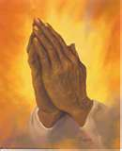

As our prayer list grows, please remember to pray for everyone on the list. Also, please call the office to add or remove names on the prayer list. God Bless you…

Nominate a Volunteer
The 2015 Diocesan Recognition Banquet, honoring those who give so much to our parishes – our volunteers – will be held on Friday, April 17th. To nominate a truly deserving volunteer or to attend the banquet, contact the office for more information.

NOTICE:
*Father will be hearing confessions in the church after 9 am mass on Thurs., March 12th

Lenten Reconciliation Service
The Penance Service will be a beautiful experience of God’s grace & forgiveness. Mark your calendar and join us: Wed., March 18th at 6:30pm in the Church with visiting priests.
Servicio de Reconciliacion Cuaresmal
Acompañanos en una hermosa experiencia de gracia y perdón el miercoles, 18 de Marzo a las
6:30 pm en la iglesia.

Catholic Services Appeal 2015
Another year of CSA has begun. Our parish goal is $29,870.66. All donations that go over our goal will return back to the Parish. Your donation helps fund very important programs & ministries. CSA is also on the web: www.catholicreno.org. Pledge cards are in the back of the church so please remember to pick it up. You may turn it into the Parish Office or put in the collection basket.

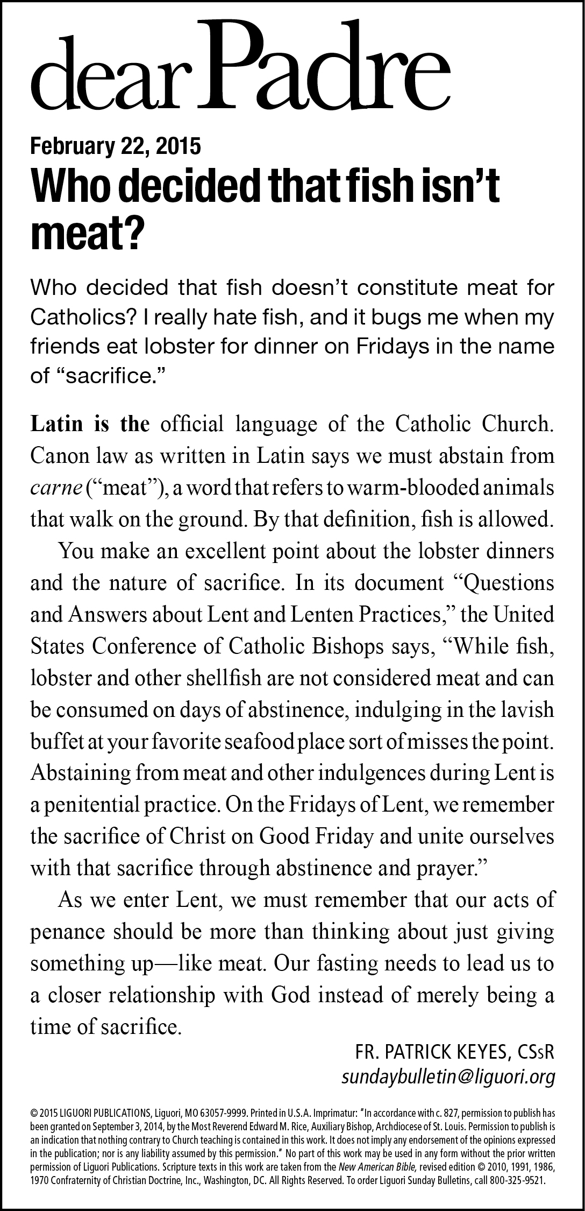

CRS RICE BOWLSwww.crsricebowl.org
This Lent, our parish is participating in Catholic Relief Services Rice Bowl, a faith-in-action program that can help each of us experience our Catholic faith in a new way, by living in solidarity with the world’s most vulnerable & poor. Our journey with CRS Rice Bowl begins in Tanzania, where a simple soybean is changing lives! What
actions can you take this Lent to change
lives—at home and around the world?
Pick up your Rice Bowl in the back of the
Church today.

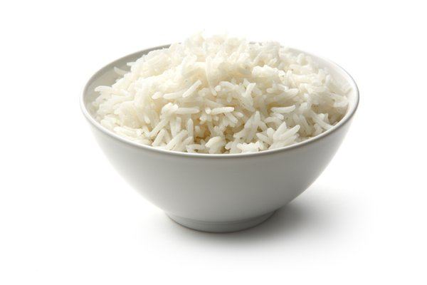

Necesitamos voluntarios que hallan terminado al menos sus estudios de preparatoria en México para ser asesores para aquellos que quieran terminar su primaria y secundaria aqui en Yerington. Favor de llamar al Padre Jorge al 463-2882.
Hambre de una vida mejor
Nuestra jornada con Plato de Arroz de CRS comienza en Tanzania, ¡donde una simple soya está cambiando vidas! ¿Qué acciones pueden tomar esta Cuaresma para cambiar vidas — en casa y en todo el mundo?

The next Worldwide Marriage Encounter Weekend will be April 17-19 in Sparks, NV. For more information contact Terry or Janet at (916) 489-3464 or visit the website at: http://www.sacramentowwme.org. This is a great way to enhance your relationship & enjoy a weekend together.

A Lenten Prayer
God, heavenly Father, look upon me and hear my prayer
during this holy Season of Lent. By the good works You inspire, help me to discipline my body and to be renewed in spirit. Without You I can do nothing. By Your Spirit help me to know what is right and to be eager in doing Your will.
Teach me to find new life through penance. Keep me from sin, and help me live by Your commandment of love.
God of love, bring me back to You. Send Your Spirit to make me strong in faith and active in good works. May my acts of penance bring me Your forgiveness, open my heart to Your love, and prepare me for the coming feast of the Resurrection of Jesus. I ask this through our Lord Jesus Christ, Your Son, Who lives, and reigns with You and the Holy Spirit, one God, forever. Amen.

CONGRATULATIONS TO JORDYN CORKERN! Her beautiful baby boy, LUCAS DALE, was born on Jan 28, 2015. Our gift has been presented to this new mom & we thank her for letting us celebrate with her in "God's Miracle of Life.”
We are still in need of many baby items! Some of the items are; hooded towels, boys or neutral, sweaters/hooded sweatshirts, shirt & pant sets, boys or neutral, burp cloths....there is a complete list of items that we use in the layette on the back table. Donation envelopes are in the back; in case you would rather we did the shopping for you. Remember to write "ABC" on your check or put cash in the marked envelope! Thank you all for your help!


ST PATRICK’S DAY DINNER
Mark your calendar for Sunday, March 15th. Adults $17.50, children under 12 $10.00. Cocktails at 5 pm, dinner at 6 pm. Buy tickets after 7 pm or 8 am mass or at the door.

Please support the Knights of Columbus & purchase a raffle ticket for the 60th Annual Seminary
Education Fund. Tickets are $1.00 each &
can be purchased from the Knights or
from the Office. First prize is $1,000 cash!
Purchase your tickets today!
MARK YOUR CALENDARS
*Liturgy Meeting, Tuesday, February 24 at 6:30 pm in the Office Conference Room*
*Next weekend will be the Anointing of the Sick after each mass*
* BINGO! Sunday, March 1st at 2 pm in the Catholic Center
¡ BINGO! Domingo, 1 de marzo a las 14:00 en el centro católico*
*Tues, March 10 at 5 pm, Finance Committee meeting in the Office Conference Room*
*Wed, March 11 at 6 pm, Parish Council meeting in the Office Conference Room*
*Wed, March 11, Knights of Columbus meeting in the Catholic Center*

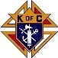
Our food pantry is in need of non-perishable food. We are in need of soups, fruits, vegetables, cereal, peanut butter, jelly, boxed side dishes, and juice. Please drop-off your donation at the office.


