Palm Sunday of the Passion of the Lord


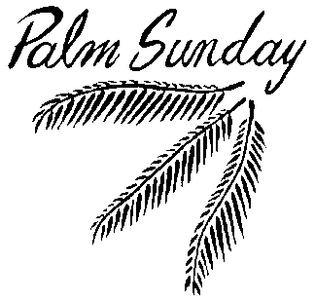

March 28/29, 2015



USHERS For March

Saturday 7pm - Volunteers
Sunday 8am – Kay & Beth Dory
Sunday 10:30am-Volunteers
Communion Minister to the Sick
March 29 Mariann Marich 463-3577
Please inform the Eucharistic Minister of any Catholic who is homebound and wishes to receive the Eucharist.

THE GIFT OF TREASURE
With gratitude for the gifts they have received, parishioners & visitors made a joyful gift of:
WEEKEND of MARCH 21/22, 2015
Holy Family $1,566.04
Smith Valley $750.00
OLPH (Hawthorne) $551.10

MASS INTENTIONS
March 28th-April 3rd, 2015
SAT 28 10:00 am +OLPH
4:30 pm +Angelo & Blanca Grosso
7:00 pm +Joe Dini & Frank Matheus
SUN 29 8:00 am +Goldie Christine Pinkerton
10:30am +Carol Ernst
MON 30 +NO MASS
TUE 31 +NO MASS
WED 1 9:00 am +Arnold Sciarani
THUR 2 7:15 pm +Holy Thursday
FRI 3 3:00 pm +Good Friday
7:00 pm +Good Friday (bilingual)

Our Prayer List
Tess Barcellos Mike Lommori
Michael Lackey Guadalupe Olague
Virginia Mantz Alicia Olague
Marty Datenan Edward Seal
Robert Calderon Priscila Wilson
Kayla Cornejo Lilia Madera Zarazua
Kiley Corkern Debbie Tillatson
Jack Pursel Joseph Caughlin
Patty Nicoll Judie Cleary
Ken Bean David Johnson
Gonzalo Velasquez Flores Nancy Swehla
Debbie Varnado Pat Giomi
Pat Branson Robert Lindstrand
Trisha Benetti Wendy Matheus Rogers
Daniela Cervantes Danny Helgeson
Joe Cleary Lorraine Conroy
Patti Carlton Ron Milligan
Charles Burr Buzzy Deckert
Lloyd Giovacchini Amanda Borges
Joshua Presley Eloisa Orozco
Dave Aaron Ray Costa
Irene Orozco Benavidez Lucille Simpson
Terry Sepsey Eileen Lopez
Jo Marriott Beau Roberts
Wanda Menesini David Giorgi
Olive Pursel Ray Carrasco
Kimberly Patton Gene Castles
Jim Cox Carol Dyhr
Ron Patton Selerino Bovilla Alaniz
Ginger Charles Tony Valladao
Loren Brown Joy Laubacher





Assisting our Neighbor
25% of contributions to CRS Rice Bowl remain in our diocese, helping to support local poverty hunger alleviation programs. This week we pray for people in our own community who struggle with poverty and hunger. Give to your Rice Bowl to support programs that help the poor in our own community, as well as in communities around the world.
Do Not Forget to return your CRS Rice Bowl donations by April 3rd (Good Friday).

LENT 2015-HOLY WEEK SCHEDULE
Daily Mass at 9:00 am Wed., April 1st
Holy Thursday Mass April 2nd OLPH in Hawthorne at 5:00 pm; and at Holy Family (bilingual) at 7:15 pm
Good Friday Service April 3rd Passion of the Lord at Holy Family at 3:00 pm & 7:00pm (bilingual)
Saturday Night Easter Vigil April 4th at Holy Family at 7:30 pm
Easter Sunday Mass April 5th at 8:30am & 10:30am (bilingual) at Holy Family with Fr. George Wolfe
9:00am at St. John’s in Smith Valley with Fr. Arias
2:00pm at OLPH in Hawthorne with Fr. Arias

NOTICE:
If you would like to attend the Annual Volunteer Recognition Banquet on April 17th, call the Church office for reservations.

Celebrate Divine Mercy Sunday with Bishop Randolph Calvo at IMMACULATE CONCEPTION CHURCH on Sun, April 12 at 2:30 p.m., 2900 N. McCarran & Pyramid Blvd. There will be a presentation on the message of Divine Mercy, exposition & benediction of The Blessed Sacrament, The Divine Mercy Chaplet prayer followed by veneration of the Blessed Image of Divine Mercy & a 1st Class Relic of St. Faustina.
Contact Maria Hernandez at 229-0368.

Father will hear confessions on Wed, April 1st, after mass.
Divine Mercy Sunday, April 12th at St. John’s 3pm Mass.

There are envelopes in the back of the church for Easter Flower Donations. Please pick one up.

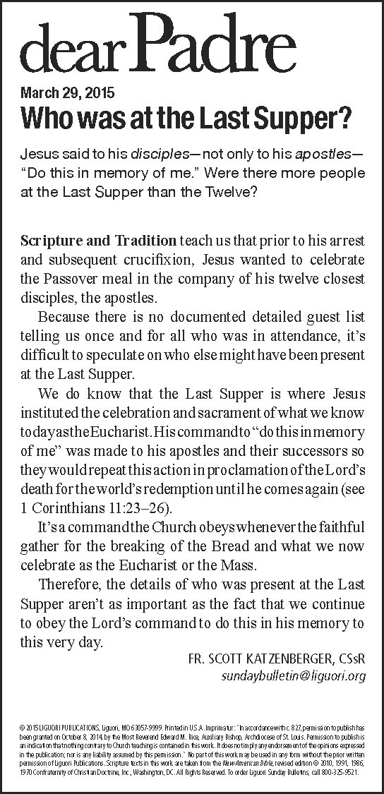

Good Friday Second Collection for Holy Land
Christians around the world are united in a special way during Lent, Holy Week and Easter. Our hearts, minds and prayers are especially aware of the Holy Land. Our parish, once a year on Good Friday, is called on to support Christians in the Holy Land. Many Christians there depend on the collection for their lives. As a pontifical collection requested by Pope Benedict XVI, the annual Good Friday collection offers a direct link for parishioners to be witnesses of peace and to help protect the Holy Places. Franciscans and others in the Holy Land are housing and feeding the poor, providing religious formation and education, maintaining shrines and parishes, and conducting pastoral ministry.
Please be as generous as your abundance allows.

Necesitamos voluntarios que hallan terminado al menos sus estudios de preparatoria en México para ser asesores para aquellos que quieran terminar su primaria y secundaria aqui en Yerington. Favor de llamar al Padre Jorge al 463-2882.

Clase de Ingles
Te gustaria aprender Ingles o mejorar tu Ingles?
La programa de ESL de Norte Nevada va empezar clases el lunes, 6 d.abril. Las clases van hacer cada lunes y miercoles en la tarde, de 7:00 a 8:00 pm en la salon parroquia de la iglesia Holy Family (311 Virginia St). Habra grupos para los principiantes y ostro para los que saben poquito y quieren aaprender mas. Las clases son gratis. Vengan el lunes, 6 d’abril, 2015, para mas informacion, y inviten a sus familias y sus amigos para esta gran oportunidad!
La clase epieza para 6 d’abril 2015. Las clases son gratis!

The Parish Office will be closed on Good Friday,
April 3rd

Upcoming Meetings
*Knights of Columbus meeting Wed, April 8th at 7 pm
*St. Anne’s Guild Luncheon/meeting Thurs, April 9th Communion Service at 11:00 am
*The First Crown Meeting for the Portuguese Society will be on Fri, April 10th at 7 pm, at Elsie Brower’s home
*Parish Council meeting Tues, April 14 at 6 pm
*Finance Council meeting on Wed, April 15th at 5pm
*St John’s Advisory Council meeting on Tues, April 22nd at 6pm in Smith Valley
*Knights of Columbus Pancake Breakfast, Sun, April 19th, after 8 am mass
*Italian Catholic’s Dinner Sun, April 19th 5-9 pm

Spring is here & we need volunteers to help
Clean-up the exterior of the Virginia St House
& prepare it for painting. May 2 & May 16
are scheduled as dates to work.
Come join in the FUN!

If you would like to donate an Easter Lily
in memory of your Loved One, to decorate
the Church for Easter, please drop it off at
the Church Office after Palm Sunday. Be
sure to let the office know in whose
memory you are donating it so we can
acknowledge them in our prayers.

next Worldwide Marriage Encounter Weekend will be April 17-19 in Minden, NV. For more information contact Steve or Jamie Wood at (775) 901-1158. To register contact Terry or Janet at (916) 489-3464 or visit the website at: http://www.sacramentowwme.org.
This is a great way to enhance your relationship
and enjoy a weekend together.

Catholic Services Appeal 2015
We would like to thank all those of you who have made your pledges for the year! Our parish goal is $29,870.66. Anything that goes over our goal will return back to the Parish. CSA is also on the web: www.catholicreno.org.
Families that have pledged: 67
Total Amount Pledged: $22,155.00
Total Cash Received: $16,520.00

Why do Christians venerate the cross?
Adoration or veneration of an image or representation of Christ's cross does not mean that we actually adore the material image, of course, but rather what it represents. In kneeling before the crucifix and kissing it we are paying the highest honor to our Lord's cross as the instrument of our salvation. Because the Cross is inseparable from His sacrifice, in reverencing His Cross we, in effect,
adore Christ. Thus we affirm: 'We adore Thee, O
Christ, and we bless Thee because by Thy Holy
Cross Thou has Redeemed the World.'






