
11704 DULEY STATION RD. UPPER MARLBORO, MD 20772-7995
PHONE: 301-856-3880
FAX: 301-856-3944

Reverend Roger A. Soley, Pastor

Dave Desmaris, Grand Knight/Knights of Columbus

Cheryl Tyiska Joseph M. Nappi
Wednesday Administrative Assistant Accountant
Jill Primrose
Administrative Assistant
Mass Schedule:
Sacrament Information:
Sacrament of Reconciliation: Saturday, 4:00 - 4:45 PM (Church)
Infant Baptism:
Kindly call the priest or secretary at the rectory to make arrangements for the baby’s Baptism.
Marriage:
Please call the priest or secretary 6 months prior to a marriage.

Saturday: 8:30 a.m. Saint Joseph Center
Saturday Vigil: 5:00 p.m. Holy Rosary Church

Daily (M-F): 8:00 a.m. Saint Joseph Center

Sunday: - 9:00 a.m. Holy Rosary Church
11:00 a.m. St. Joseph Center

Holy Days: 8:00 a.m. St. Joseph Center
7:00 p.m. St. Joseph Center

Parish Council Members
Eileen Ford 856-5529 David Julian 856-4313
Celia Culbert 952-1522 Susan Marciniak 782-7868
Rosario Dickerson 952-8115 Ron Nosalik 868-6826
Betty Elliott 856-1142 Juanita Pointer 599-7034
John Ferguson 856-3626 Jeanette Zak 627-8323

Parish Finance Council Members
Steve Proctor (Chair) 868-4872 Chester Gryskewicz 599-6665
Nancy Brazerol 627-3763 Juanita Pointer 599-7034
Raymond Ford 856-5529

Parish Registration
Everyone is encouraged to register in the Parish. Take and fill out a registration form at the rear of the Church or Center and place it in one of the collection baskets or drop it off or mail it to the rectory.
Parish Web Site: www.mostholyrosarychurch.org Washington Archdiocese: www.adw.org Share Web Site: www.sharedc.org MD Catholic Conference: www.mdcathcon.org

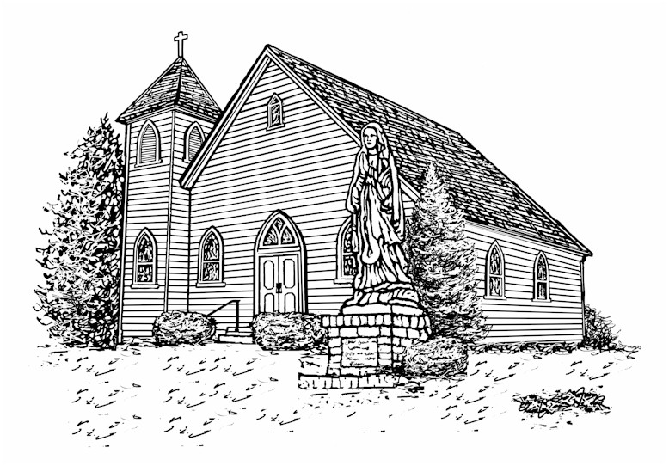
CATHOLIC CHURCH ---ARCHDIOCESE OF WASHINGTON--
Most Holy Rosary

Welcome, New Parishioners and Visitors!

Most Holy Rosary Church is a vibrant, caring, and faith-filled community. We welcome all new members as well as those who want to know more about the Catholic faith. To join the parish, please contact the parish office for a registration form. You may return the completed forms in the Sunday collection basket, by mail, or by bringing them to the Rectory during office hours.

We sincerely hope that you will benefit from the opportunities available in our parish to develop and bless your faith. There are a number of important ministries in our parish and your active participation will enhance our community life, particularly through the Hospitality & Outreach Committee.

Please let us know if you are relocating or moving away by sending us an email, dropping us a note, or by telephoning the parish office. Thank you!

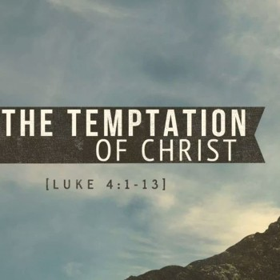
May 25 - 26

Saturday, 5 pm | John Fluck (D) |  |  | Pro Populo
Sunday, 9 am | Pro Populo |  |  | Daniel Donovan (D)
Sunday, 11 am | Joseph Grushka (D) |  |  | Vincent, Stephanie  & Samia Roper (D)
May 27 – June 1

Monday, 8 am | Fr. Seamus Kuebler (D)
Tuesday, 8 am | Joanne Morony (D)
Wednesday, 8 am | Jean Vanier (D)
Thursday, 8 am | Fr. Harold Buckley (D)
Friday, 8 am | DN. of the Archdiocese (L)
Saturday, 8:30am | Archbp. Wilton Gregory (L)
June 1 – June 2

Saturday, 5pm | Marylee Proctor (D)
Sunday, 9am | John Strong & Strong/  Hawke Families (D)
Sunday, 11 am | Pro Populo

Thank you for supporting your parish!
Offertory, May 19 $4,661

This portion of John's Gospel comes near the end of the first of four chapters that make up Jesus' long farewell discourse at the Last Supper. This section sums up the themes of the opening of the discourse: the Christian's life is not shaped by Jesus’ absence but by God's abiding presence; God’s presence overcomes anxiety about God's absence; and the present holds in it the seeds of a fresh future shaped by love, not fear.
We get a glimpse of some of the other themes of the farewell discourse: Jesus’ relationship with the Father and the disciples’ relationship to Jesus connect the disciples to the Father as well. Jesus promises to send an Advocate or intercessor who will remind

the disciples of everything that Jesus taught them and bring them peace.
Jesus is preparing his disciples in advance for his absence so that they will continue to believe in him and not feel all alone after his return to the Father. After the initial excitement of his Easter appearances, Jesus will remain with his followers in a very different way throughout the centuries.
As the Easter season comes to an end, the liturgy reminds us that Jesus remains with us through the Holy Spirit, who teaches us everything we need to know, reminds us of all that Jesus taught, and brings us peace. (Redacted from Sunday Connection, Loyola Press)

hospitals, correctional facilities, pregnancy centers, nursing homes, homeless shelters, food pantries, fire and police department chaplaincies, institutions for persons with disabilities and immigration service providers. Outreach to the least of our sisters and brothers is one of the primary thrusts of the deacon’s call.
Many deacons receive special training to serve as masters of ceremony at Masses celebrated by auxiliary bishops. At Mass, deacons proclaim the Gospel and the Prayer of the Faithful, prepare the altar with the gifts of bread and wine, invite the congregation to exchange the Sign of Peace, distribute Holy Communion and dismiss the assembly. They have the mandate to teach and preach in the name of the Church to both believers and those who have not yet accepted the message of Christ.
Deacons are ordained clergy of the Catholic Church. To become a deacon, one receives the Sacrament of Holy Orders at the hands of a bishop. They may baptize, witness marriages, preside at funerals and wakes and administer Holy Communion to the sick and dying. Most permanent deacons have secular jobs, where they provide an ordained witness to Christ in their workplaces. The majority of permanent deacons are married men with families. Contact the Office of the Permanent Diaconate at 301-853-4550 for more information.

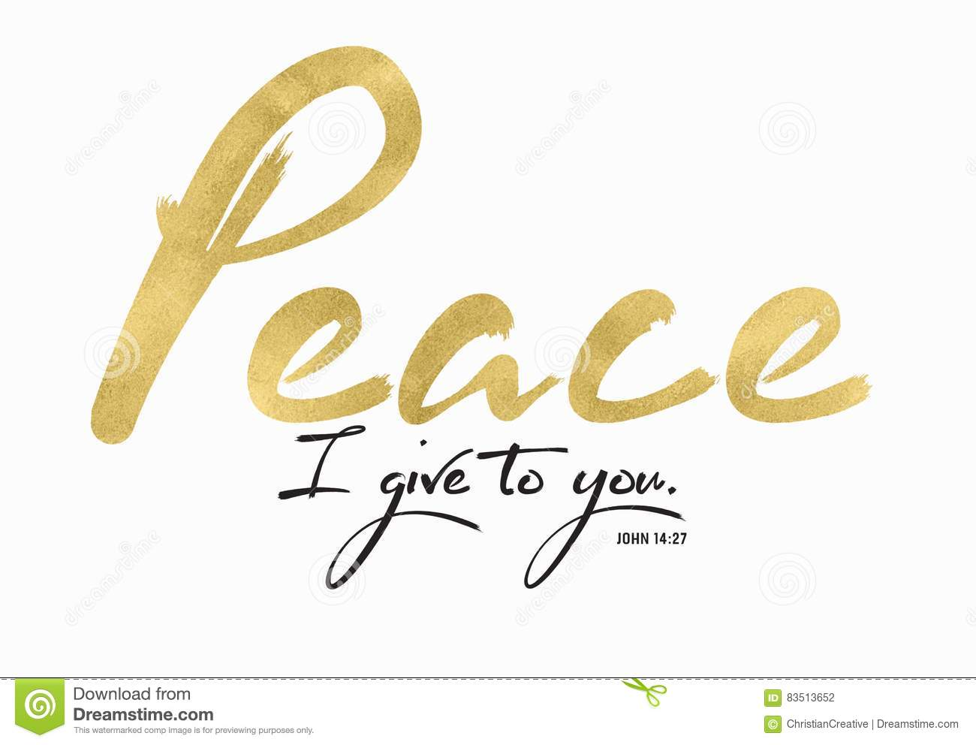
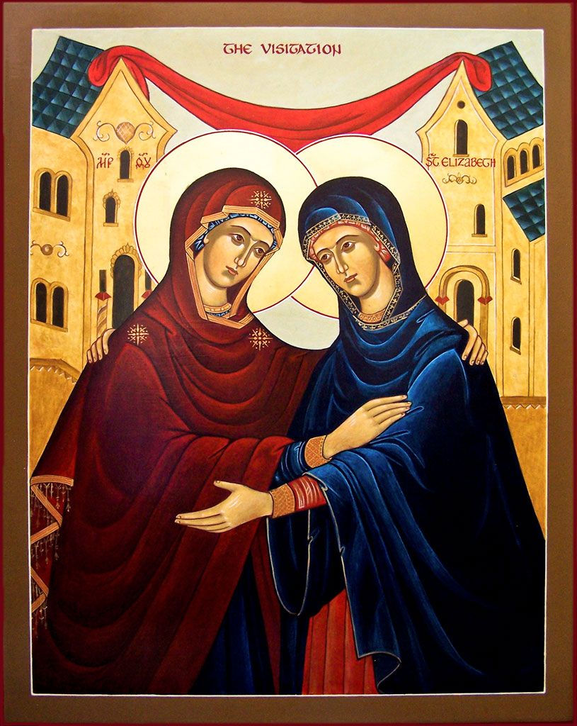
sixth Sunday of easter
May 26, 2019



nday in Ordinary Time
January 15, 2017
 This Sunday we break from our reading of Matthew's Gospel to read from John's Gospel. We heard Matthew's account of Jesus' baptism last week, on the feast of the Baptism of the Lord. Today, we hear John the Baptist's testimony about Jesus. John's differs from the other Gospels because he does not describe Jesus' baptism by John the Baptist. Instead, John the Baptist announces that he knows that Jesus is the Son of God.
John the Baptist sees Jesus approaching and cries out, giving witness about who Jesus is. John says that he saw the Spirit descend upon Jesus. By this sign, John the Baptist knew that Jesus was the one who is to come after him.
John the Baptist uses two titles for Jesus that are familiar to us. John calls Jesus the “Lamb of God” and the “Son of God.” By using these titles, John the Baptist identifies Jesus' ultimate purpose: to redeem sinful humanity.
John the Baptist's testimony about Jesus clearly distinguishes John's baptism from the Baptism that Jesus will inaugurate. John baptizes with water; Jesus will baptize with the Holy Spirit. John also puts his practice of baptism in the context of Jesus' ministry. The purpose of John's baptism was to make Jesus known to Israel.
John the Baptist's sense of purpose is clearly identified in this reading: he baptized in order to prepare for and make known the ministry of the One who was to follow. John's witness is an excellent example of what it means to be a disciple. By our Baptism, we are called to make Jesus known to all the world by our words and by the witness of our lives. ~ Redacted, Sunday Connections, Loyola Press

Sister Agnes Clare, Sister Brauna MacFarlane, Judy Anderson, John Anderson, Monica Anderson, Dominic Arman, Margaret Beaver, Frank Bello, Frederick Bello, Gladys Benton, George Berry, Varonica Best, Ruth Block, Jennifer Boniface, Faith Britt, John Burns, Paul Cahill, Al Camp, Lilian Caplins, Barbara Carroll, Mary Cave, Phyllis Chambers, Jackie Chancio, Marco Clark, Mary Closson, Angel Colbert, Theresa Colbert, Joshua Colbert, Sterling Colbert, Sr., Elizabeth Cook, Bob Coughlan Diana DelRicco, Sister Brona, Gene Evans, Mary Farrimond, Richard Farrell, Jr., Ricky Farrell, III, John Fluck, Bp. David Foley, Eileen Ford, Jacqueline Ford, Ernestine Fredette, Frederick Fricker, Joshua Gardener, Joyce Green, Donald Griffith, Sonia Grushka, Monica Harley, Frances Hawkins, Ethel Herring, James Hodges, Andy Hoffman, Joe Holley, Msgr. Richard Hughes, Robert & Liz Isom, Rose Jackson, Theresa Jackson, John Jako, Albert Jones, Jr., Wayne Jones, Marianne Julian, Deacon Kelso, Christine Kidwell, Marjorie C Kelley, Tim Kiley, Marion Kneas, Michael Langway, Nancy LaVine, Nancy Lingerfelt, Miriam Love, Fr. John Lynch, Rosalie Lynn, Pete Mulladay, Paul Martin, Fr. John Mattingly, Barbara Mattis, James McFadden, Betty McFarlane, James McLaughlin, Noah McLaughlin, Peggy McLaughlin, Gary McLean, Joan McMurrer, Rachel McMurrer, T.J. Mauck, Richard Mizak, Charles Moroney, Deacon Montgomery, Damiana Murphy, Murray Family, Robert Mutchler, Joe Nappi, Michael Nappi, Paul Nappi, Ralph Nasatka, Agnes O’Malley, Jessica O’Neill, Donald Point, Sally Presti, Barbara Proctor, Marvin Proctor, Nellie Proctor, Zita Proctor, Bob Richards, Roxanne Riker, Pat Robinson, Beverly Sadler, Leisl Shreader, Audrey Smith, Candace Smith, Mary Smith, Fr. John Smolko, Charles Snowden, Jeni Stepanek, Bernie & Melissa Spicer, Maurie Stevens, Frances Stokes, Barb Sullivan, Mary H. Swann, Austin Swann, Joanna Thompson, Doyle Underwood, Jackie Vanacore, Eric Van Tassel, Bessie Walger, Eloise Wells, Antonio White, Demar White, Regina Taylor-White, Peter White, Robyn White, Lamar Wilson. Lord, hear our prayers for those who are ill and in need of consolation.

Collection for Church Missions in the United States and the Archdiocese for the Military Services
Today, we take up a joint second collection. The collection for Church Missions in the United States supports home mission dioceses in this country that are unable to offer their people basic liturgical, pastoral, and service ministries without outside help. It also supports vulnerable Black and Native American communities with funds for parish support and evangelization needs. The Archdiocese for the Military Services provides the Catholic Church’s full range of pastoral ministries and spiritual services to those in the United States Armed Forces, and is therefore responsible for more than 1.8 million men, women, and children. Thank you for your generosity!

Lay Ministers Schedule
This Weekend Next Weekend
 | Lectors | Eucharistic Ministers |  | Lectors | Eucharistic Ministers
Sat. 5 pm | Wynonia Lee |  | Joyce Brooks
Sun. 9 am | John Wilson |  | TBD | Calvin Bell | Marie Harley
Sun. 11 am | Charito Turnigan |  | Geraldine Snowden, Lydia Anderson, Roberta Roper  Acolytes: Sean Oden,  Carmen Contreras | Linda Washington | Lydia Anderson, Lewis Smith, Ernest Washington  Acolyte: Markus Downs, Carmen Contreras

Mass Schedule ~ Intentions for the Week

Feast of the Visitation of the Blessed Virgin Mary, May 31Save the Date!
Sunday, September 29, after 11:00am Mass Save the Date!
Sunday, September 29, after 11:00am Mass

S. Northern | Don Retzlaff
Patricia Hall | Bernadine McConville
Lorraine Leonard | Ron Nosalik, Lewis Smith, Yvonne Quarles  Acolytes: Markus Downs, Rachel Seekford



Deacons in the Archdiocese of Washington
The first permanent deacons of the Archdiocese were
ordained in 1971. Since then, nearly 400 deacons have
been ordained. Nearly 150 deacons are in active ministry.
Many retired deacons continue to serve as well. Currently, 31 men are in formation to become deacons.
Every deacon is assigned by the archbishop to a parish,
where he exercises a liturgical and catechetical ministry.
Every deacon is also assigned to a particular “Ministry of
Charity and Justice,” which may or may not be at the
parish where a deacon serves. Examples include service at

8000 Woodyard Road
Clinton, Maryland
Please join us to pray and remember the brave men and women who made the ultimate sacrifice.
Archbishop Wilton Gregory will celebrate Mass.

Have a safe and peaceful Memorial Day holiday!

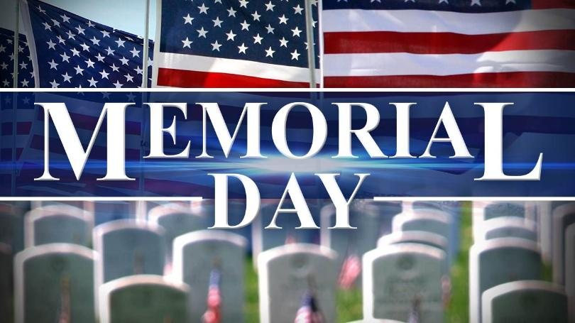

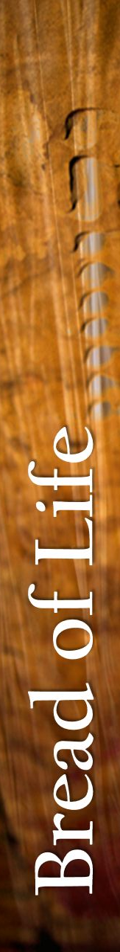

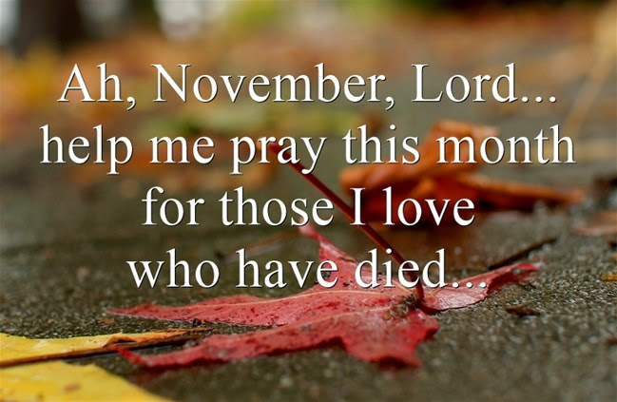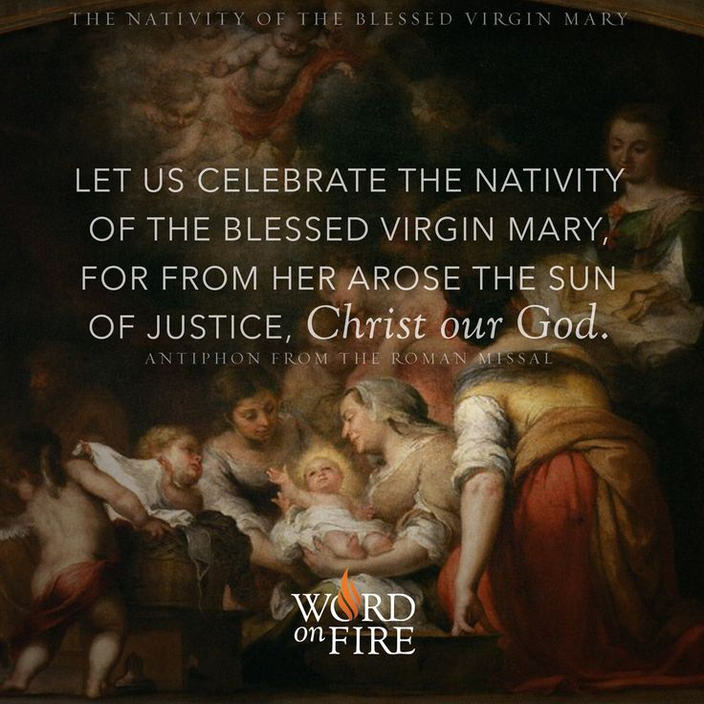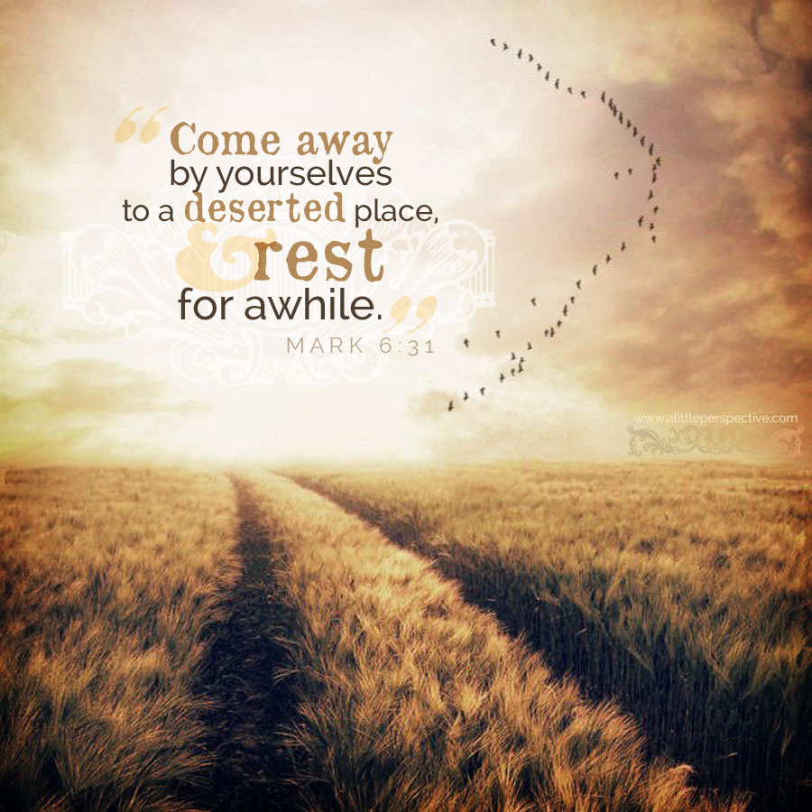
Sister Agnes Clare, Sister Brauna MacFarlane, Judy Anderson, John Anderson, Monica Anderson, Dominic Arman, Lucy Arnold, Frank Bello, Frederick Bello, Gladys Benton, George Berry, Varonica Best, Faith Britt, John Burns, Paul Cahill, Al Camp, Lilian Caplins, Mary Cave, Phyllis Chambers, Jackie Chancio, Patricia Chandler, Star Chase, Marco Clark, Mary Chestnut, Mary Closson, Angel Colbert, Theresa Colbert, Joshua Colbert, Sterling Colbert, Sr., Bob Cook, Elizabeth Cook, Bob Coughlan, Alma Davis, Diana DelRicco, Sister Brona, Gene Evans, Mary Farrimond, Richard Farrell, Jr., Ricky Farrell, III, Eileen Ford, Jacqueline Ford, Ernestine Fredette, Frederick Fricker, Adeline Godinez, Joyce Green, Donald Griffith, Fr. Tom Gude, Sonia Grushka, Monica Harley, Frances Hawkins, Ethel Herring, Deacon Carlos Hernandez, James Hodges, Andy Hoffman, Joe Holley, Robert & Liz Isom, Rose Jackson, Theresa Jackson, John Jako, Albert Jones, Jr., Wayne Jones, Marianne Julian, Deacon Kelso, Christine Kidwell, Marjorie C. Kelley, Tim Kiley, Michael Langway, Nancy LaVine, Nancy Lingerfelt, Miriam Love, Fr. John Lynch, Rosalie Lynn, Pete Mulladay, Paul Martin, Gladys Matthews, Barbara Mattis, James McFadden, Betty McFarlane, James McLaughlin, Noah McLaughlin, Peggy McLaughlin, Gary McLean, Rachel McMurrer, T.J. Mauck, Richard Mizak, Charles Moroney, Deacon Montgomery, Damiana Murphy, Murray Family, Robert Mutchler, Joe Nappi, Michael Nappi, Paul Nappi,

Ralph Nasatka, Mary Nielson, Agnes O’Malley, Jessica O’Neill, Donald Point, Sally Presti, Barbara Proctor, Marvin Proctor, Nellie Proctor, Zita Proctor, Bob Richards, Joel Rivera, Pat Robinson, Beverly Sadler, Leisl Shreader, Anna Smith, Audrey Smith, Candace Smith, Mary Smith, Patrice Smith, Fr. John Smolko, Charles Snowden, Patrick Pierre-Louis, Jeni Stepanek, Bernie & Melissa Spicer, Maurie Stevens, Frances Stokes, Barb Sullivan, Mary H. Swann, Austin Swann, Joanna Thompson, Doyle Underwood, Josie Vargara, Jackie Vanacore, William Vogelson, III, Bessie Walger, Edward Ward, Bessie Watson, Antonio White, Demar White, Regina Taylor-White, Peter White, Robyn White, Lamar Wilson, Frank Zak. Lord, hear our prayers for those who are ill or in need of consolation.

Most Holy Rosary Council 11511,
Grand Knight Ed Donovan, dcdnova@netscape.net

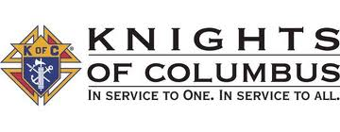
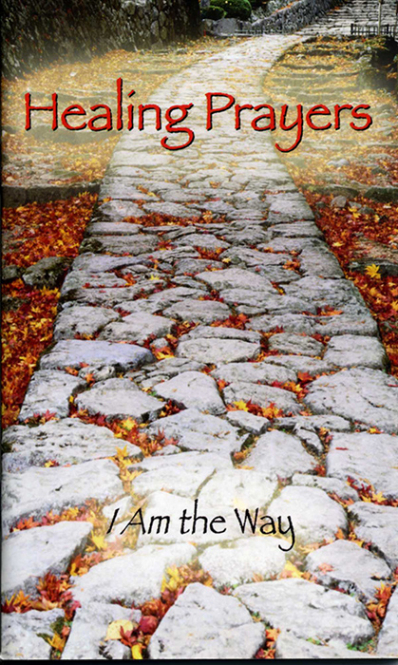

God reveals himself to us so we can reveal God to others, so we can proclaim the Good News
of God’s love by our very lives – the very purpose of our existence, of our life.

First Reading: Acts of the Apostles 15:1-2,22-29 Responsorial Psalm: Psalm 67:2-3,5,6,8
Second Reading: Revelation 21:10-14,22-23 Gospel: John 14:23-29

